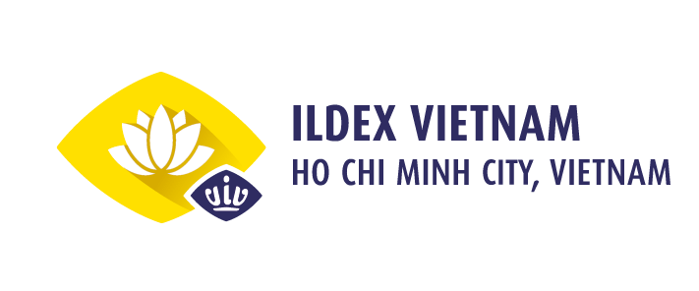

PRESS RELEASE

The Kick-Off Meeting for The 8th International Livestock, Dairy, Meat Processing and Aquaculture Exposition, Vietnam on June 30th, 2022 at Majestic Saigon, Ho Chi Minh City, Vietnam.
Cordially invited to the meeting are delegates from Department of Livestock Production (Ministry of Agriculture and Rural Development); National Center for Agricultural Extension (Ministry of Agriculture and Rural Development of Vietnam); Trade Promotion Department (Ministry of Industry and Trade of Vietnam); Vietnam Feed Association, Vietnam Livestock Association; Vietnam Ruminant Husbandry Association; The faculty of Veterinary and Animal Husbandry (Nong Lam University); and with the presence of press agencies, organizations and enterprises in livestock industry.
ILDEX Vietnam - The International Livestock, Dairy, Meat Processing and Aquaculture Exposition, Vietnam organized by VNU Exhibitions Asia Pacific Co., Ltd and Minh Vi Exhibition and Advertisement Services Co., Ltd is the biennial large-scale event that has attracted much attention from professionals and industry players around the world.
ILDEX Vietnam 2022 - The 8th International Exhibition on Livestock, Veterinary Medicine, Dairy, Meat Processing and Aquaculture will be held from August 3 to 5, 2022 at Saigon Exhibition and Convention Center. Saigon (SECC), District 7, Ho Chi Minh City. This is the first international livestock exhibition to return to Vietnam after the Covid-19 pandemic, which will be a great opportunity to connect and diversify the global supply chain, promptly restore and enhance opportunities. production-business, updating market information, updating techniques and new technologies after nearly 3 years of interruption due to the pandemic.
ILDEX Vietnam 2022 will welcome more than 200 exhibiting companies and from around 25 countries: Austria, Belgium, Canada, China, Czech Republic, Denmark, France, Germany, Italy, Japan, Korea, Netherlands, Thailand, United Kingdom, USA and many more with many prominent brands such as: EVONIK, HUALI, BEHN MEYER, PEJA, LUCTA, MIAVIT,… The exhibition has national pavilions such as: France, USA, Italy, Korea, Brazil, Czech Republic…
ILDEX Vietnam 2022 is expected to welcome around 10,000 visitors from Vietnam and many other countries in the region. During three days, a wide array of stand-out activities will be included: the comprehensive seminar series being held across all three days providing with knowledge, advices and strategies to help business growth and development; Face to face Business Meetings between visitors and exhibitors will be arranged by Organizers to help both sides find their targeted prospects; VIP Buyer Program brings exhibitors a good chance to reach the top buyer and expand the business network; and many other valued activities. Currently, 95% of exhibiting space of ILDEX Vietnam 2022 has been occupied underlining the large interest.
The Kick-off Meeting for ILDEX Vietnam 2022 includes interesting industrial topics presented by top speakers and experts from livestock-related associations and organizations. In addition, the Organizers will hold a panel discussion on “ILDEX Vietnam – The Gateway Through Vietnamese Animal Protein Production Market 2022”. This facilitates the chance for enterprises to gain necessary updates, access to advanced technologies, as well as to promote business opportunities with potential partners.

For more information:
VNU Exhibitions Asia Pacific Co., Ltd.
E-Mail: saengtip@vnuasiapacific.com | Web: www.vnuasiapacific.com
Minh Vi Exhibition and Advertisement services Co., Ltd. (VEAS)
Website: www.ildex.com.vn www.ildex-vietnam.com.vn
Tel: +84 28 3848 8561
Email: info@veas.com.vn

